Project Title | Basic Matplotlib Visualization
Course | DSA0502-query processing for data science
Team Member (this report) | THARUN.V (Reg. No. 192424050)
Date | 03/09/2026

Aim
To create a dataset containing the monthly sales of an organisation for one calendar year using pandas, and to visualise that data using Matplotlib as (a) a line chart, (b) a bar chart, and (c) a pie chart, and to interpret each chart's result.

Dataset
A synthetic monthly-sales dataset was created for one year (12 months), expressed in Rs. Lakhs, with a mild seasonal pattern (a dip in February, a festive-season peak around October–November) so that the three chart types have a genuine, visible story to tell.

Month | Sales (Rs. in Lakhs)
Jan | 45
Feb | 38
Mar | 52
Apr | 48
May | 55
Jun | 60
Jul | 58
Aug | 62
Sep | 65
Oct | 78
Nov | 82
Dec | 70
Table 2.1 — Monthly sales dataset used for all three charts.

Algorithm / Procedure
- Step 1: Import the pandas and matplotlib.pyplot libraries.
- Step 2: Create the monthly sales data as a Python dictionary and load it into a pandas DataFrame.
- Step 3: Print the DataFrame and compute basic summary statistics (total, average, best/weakest month).
- Step 4: Plot a line chart of Sales vs Month to visualise the trend across the year.
- Step 5: Plot a bar chart of Sales vs Month to compare individual months directly.
- Step 6: Plot a pie chart showing each month's percentage share of total annual sales.
- Step 7: Label axes/titles/legends appropriately and save each chart as an image.

Program
The complete, runnable Python script used to generate the dataset and all three charts is listed below.

matplotlib.use("Agg")
import matplotlib.pyplot as plt

#
# 1. Create the dataset: monthly sales for one year #
data = {
"Month": ["Jan", "Feb", "Mar", "Apr", "May", "Jun",
"Jul", "Aug", "Sep", "Oct", "Nov", "Dec"], "Sales (Rs. in Lakhs)": [45, 38, 52, 48, 55, 60,
58, 62, 65, 78, 82, 70]
}
df = pd.DataFrame(data) print(df.to_string(index=False))
print("\nTotal Annual Sales : ", df["Sales (Rs. in Lakhs)"].sum()) print("Average Monthly Sales : ", round(df["Sales (Rs. in Lakhs)"].mean(), 2)) print("Best Month : ", df.loc[df["Sales (Rs. in Lakhs)"].idxmax(), "Month"])
print("Weakest Month : ", df.loc[df["Sales (Rs. in Lakhs)"].idxmin(), "Month"])

#
# 2. Line chart — sales trend across the year #
plt.figure(figsize=(8, 4.5))
plt.plot(df["Month"], df["Sales (Rs. in Lakhs)"], marker="o", color="#1F3864", linewidth=2)
plt.title("Monthly Sales Trend (Line Chart)", fontsize=13, fontweight="bold") plt.xlabel("Month")
plt.ylabel("Sales (Rs. in Lakhs)") plt.grid(True, linestyle="--", alpha=0.5) plt.tight_layout()
plt.savefig("img/line_chart.png", dpi=200, facecolor="white") plt.close()

#
# 3. Bar chart — sales comparison across months #
plt.figure(figsize=(8, 4.5))
bars = plt.bar(df["Month"], df["Sales (Rs. in Lakhs)"], color="#2E5395") plt.title("Monthly Sales Comparison (Bar Chart)", fontsize=13, fontweight="bold") plt.xlabel("Month")
plt.ylabel("Sales (Rs. in Lakhs)")
plt.grid(True, axis="y", linestyle="--", alpha=0.4) plt.tight_layout()
plt.savefig("img/bar_chart.png", dpi=200, facecolor="white") plt.close()

#
# 4. Pie chart — each month's share of annual sales #
plt.figure(figsize=(7, 7)) colors = plt.cm.tab20.colors
explode = [0.08 if v == df["Sales (Rs. in Lakhs)"].max() else 0 for v in df["Sales (Rs. in Lakhs)"]] plt.pie(df["Sales (Rs. in Lakhs)"], labels=df["Month"], autopct="%1.1f%%",
startangle=90, colors=colors, explode=explode, wedgeprops={"edgecolor": "white", "linewidth": 0.8})
plt.title("Share of Annual Sales by Month (Pie Chart)", fontsize=13, fontweight="bold")

Output

Console Output
Printing the DataFrame and the summary statistics produces:

Total Annual Sales : 713 Average Monthly Sales : 59.42 Best Month : Nov
Weakest Month : Feb

All three charts saved successfully.
Month Sales (Rs. in Lakhs) Jan 45
Feb 38
Mar 52
Apr 48
May 55
Jun 60
Jul 58
Console output

Aug | 62
Sep | 65
Oct | 78
Nov | 82
Dec | 70

Line Chart
The line chart traces the month-to-month sales trend, making the overall upward trajectory of the year and the festive-season peak easy to follow.
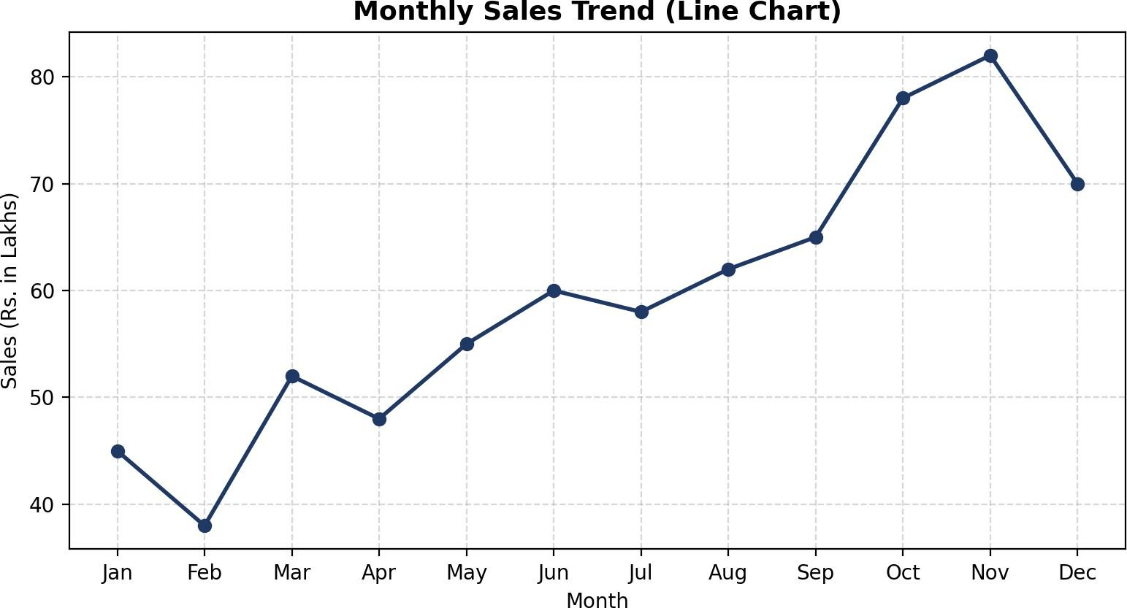

Figure 5.1 — Monthly sales trend (line chart).

Inference: sales dip immediately after January (a post-New-Year lull in February) and then climb steadily, with the fastest rise in Q3–Q4 leading into a peak in November, before easing slightly in December.

Bar Chart
The bar chart makes it easy to compare any two months directly, since each month is an independent, clearly separated bar rather than a point on a continuous trend.
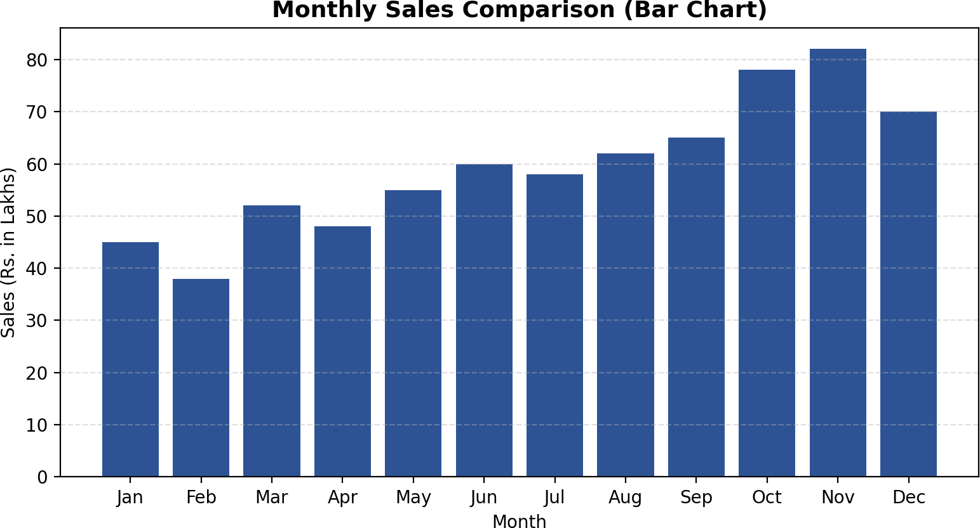

Figure 5.2 — Monthly sales comparison (bar chart).

Inference: November (Rs. 82 Lakhs) and October (Rs. 78 Lakhs) are the two strongest months, together standing well above the Rs. 59.4 Lakhs monthly average, while February (Rs. 38 Lakhs) is the weakest.

Pie Chart
The pie chart shows each month's proportional share of total annual sales, which is a view neither the line chart nor the bar chart can give directly.

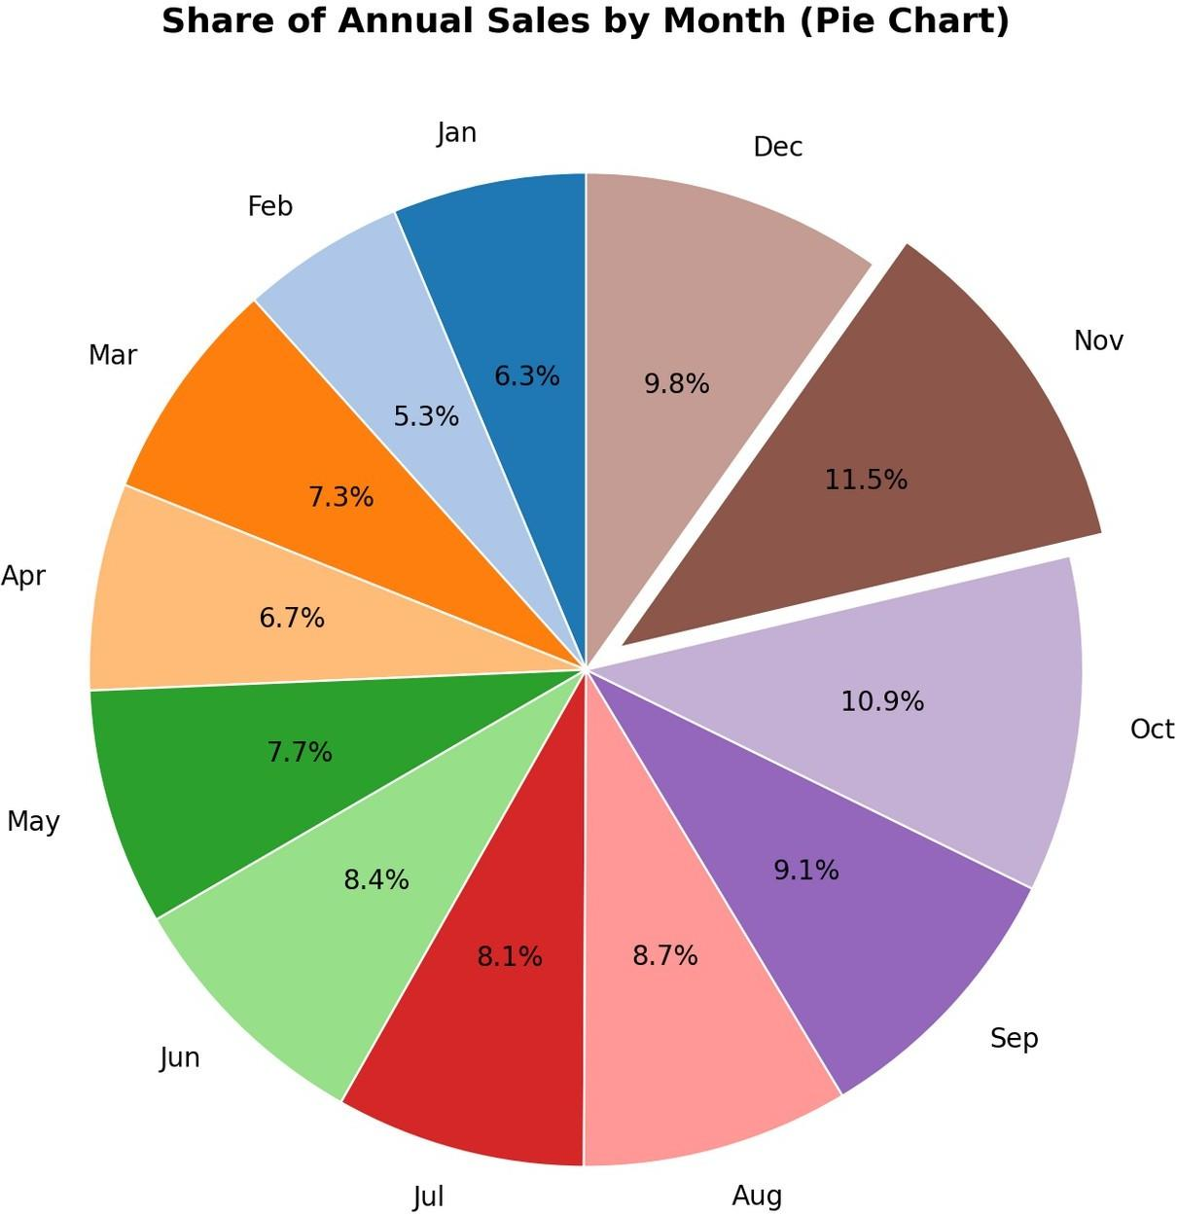

Figure 5.3 — Share of annual sales by month (pie chart); the highest-selling month (November) is exploded out for emphasis.

Inference: November alone accounts for 11.5% of the entire year's sales, and the four festive-season months (Sep–Dec) together contribute a little over 41% of annual sales from just a third of the months.

Result
A monthly sales dataset for one year was successfully created using pandas and visualised using Matplotlib as a line chart, a bar chart, and a pie chart. The line chart highlighted the overall trend, the bar chart enabled direct month-to-month comparison, and the pie chart revealed each month's proportional contribution to annual sales. The program was executed successfully and the expected output was verified.

